Experiment No: 06

**Aim:**

To post message on twitter using raspberry-pi

**Output:**

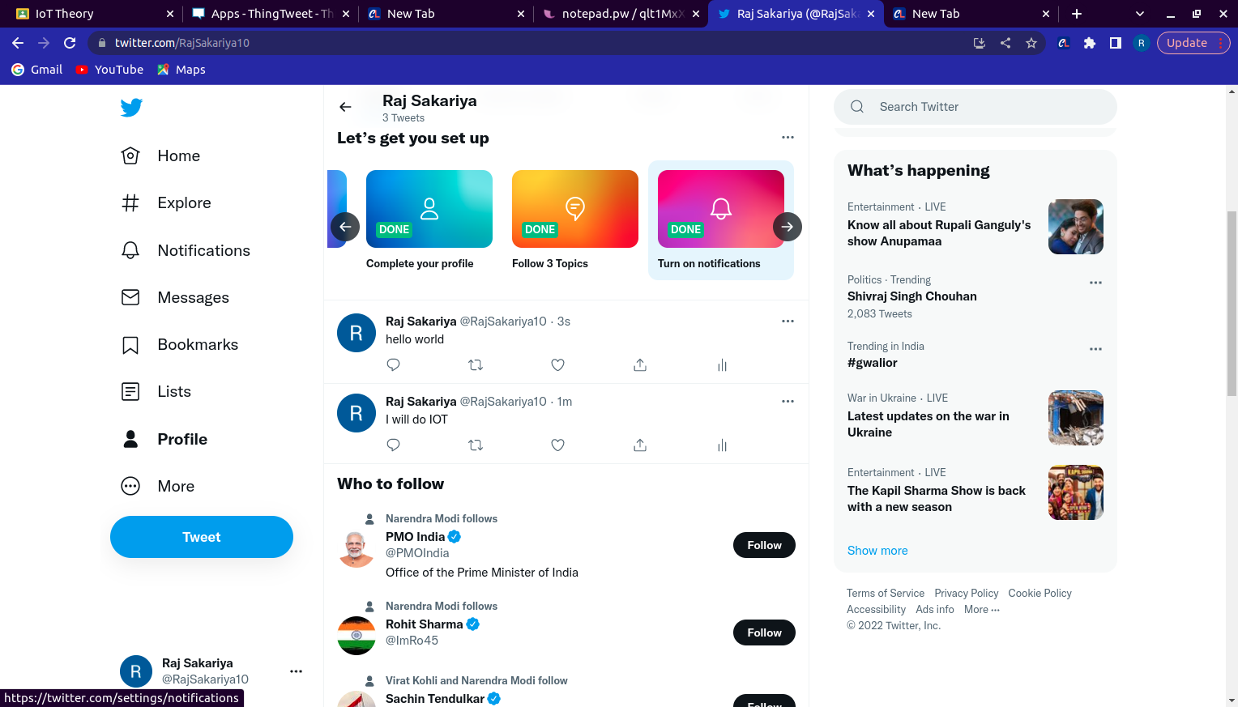

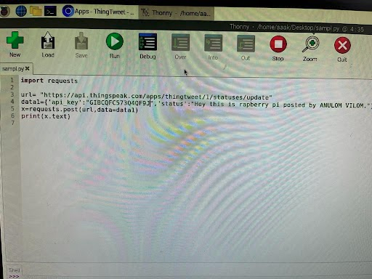

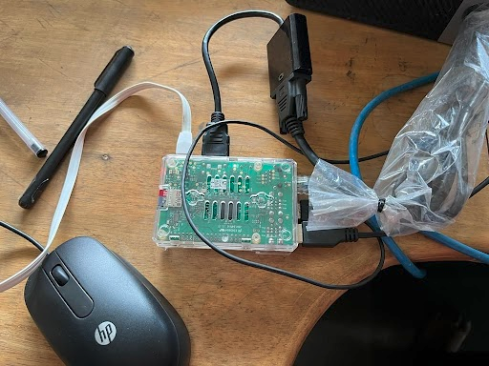

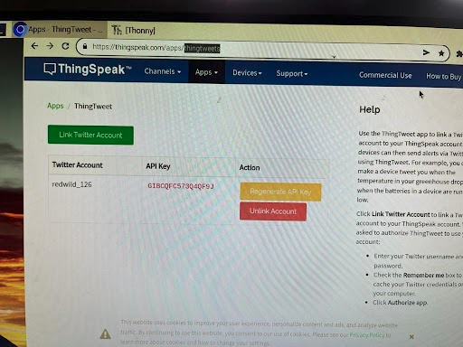

**Code:**

import requests

url = "generated url on thinktwitter"

data 1 = ('api_key':"value",'status':"value) // refer thinktwitter portal for api_key after linking your twitter account

x=request.post(url,data = data1)

print(x)